Irish Design 2015 presents
“爱尔兰设计2015”项目
New Horizon_architecture from Ireland
at the 2015 Bi-City Biennale of Urbanism\Architecture (Shenzhen)
2015年深港城市\建筑双城双年展参展作品
《新地平线——来自爱尔兰的建筑》

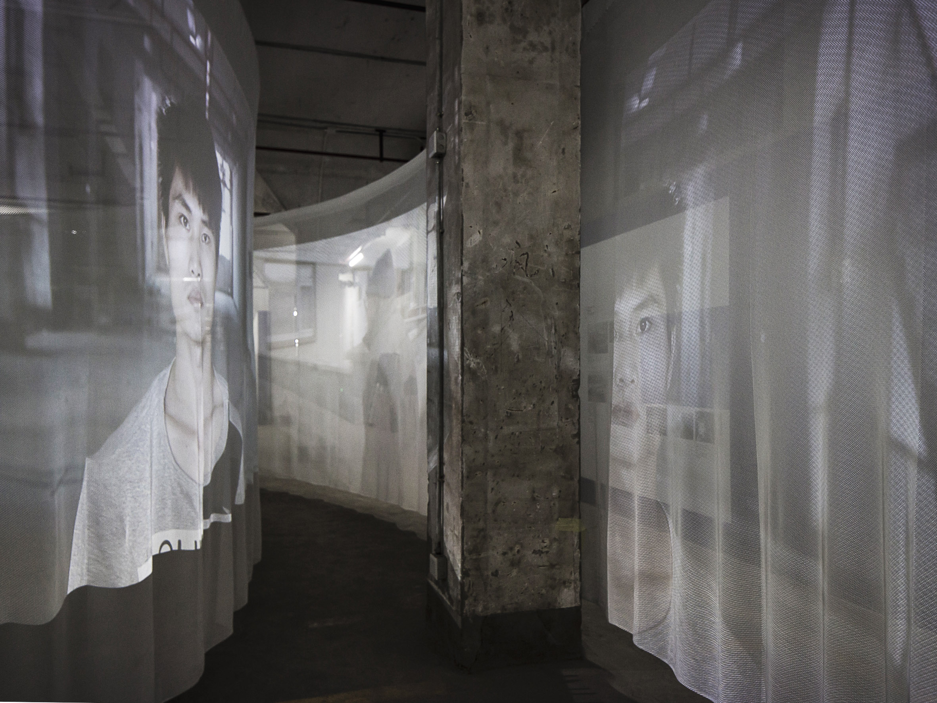
The Ireland Pavilion installation presenting photography and short films
showing the relationship between Shannon, Ireland and Shenzhen, China
爱尔兰馆内的装置展出的照片和电影短片体现了爱尔兰香侬和中国深圳之间的联系

New Horizon_architecture from Ireland, a series of presentations of the work of emerging Irish practices in three high-profile venues around the world, opens at the Dacheng Flour Factory, Shekou on December 4th 2015 and runs until March 4th 2016 as part of the 2015 Bi-City Biennale of Urbanism\Architecture (Shenzhen). For the Shenzhen iteration, a fascinating audio-visual installation of photography and film will follow the connection between the Irish city of Shannon and its historical influence on shaping the city of Shenzhen.
《新地平线——来自爱尔兰的建筑》是在全球三个备受瞩目的地点举办的一系列展览，展出爱尔兰新兴建筑师事务所的作品，此次在蛇口大成面粉厂的展览是2015年深港城市\建筑双城双年展的一部分，将从2015年12月4日持续至2016年3月4日。在深圳站，一个视听装置展出的照片和电影细致地展现了爱尔兰香侬和在其历史影响下塑造而成的深圳二者之间的关联。

New Horizon_architecture from Ireland is the flagship exhibition programme for Irish architecture and the built environment as part of Irish Design 2015 (ID2015), a year-long initiative backed by the Irish government exploring, promoting and celebrating Irish design throughout Ireland and internationally.
《新地平线——来自爱尔兰的建筑》是爱尔兰建筑和建筑环境领域的高端展览，也是“爱尔兰设计2015” （简称ID2015）项目的组成部分，该项目为期一年，受爱尔兰政府的支持，在爱尔兰国内和国际上挖掘爱尔兰设计的优秀作品，促进爱尔兰设计的发展并庆祝爱尔兰设计取得的成就。

Selected by curators Nathalie Weadick of the Irish Architecture Foundation, and Raymund Ryan of the Heinz Architectural Center at Pittsburgh’s Carnegie Museum of Art, New Horizon_architecture from Ireland will present the work of two practices in the Ireland Pavilion in Shenzhen: AP+E (Jeffrey Bolhuis and Laurence Lord) and Urban Agency (Andrew Griffin, Maxime Laroussi, Heechan park and Henning Stüben). Working with Irish photographer and filmmaker Matthew Thompson and Areaman Productions, they have created a sensory environment of concentric curtains within which two short films exhibit parallels in the daily life of both Shannon and Shenzhen today.
《新地平线——来自爱尔兰的建筑》的参展事务所均由策展人——爱尔兰建筑基金会主管Nathalie Weadick和匹兹堡卡耐基艺术博物馆海因茨建筑中心策展人Raymund Ryan——亲自挑选，此次在深圳参与爱尔兰馆设计的是Jeffrey Bolhuis和Laurence Lord创建的AP+E事务所以及Andrew Griffin、Maxime Laroussi、Heechan park 、Henning Stüben创建的Urban Agency事务所。两家事务所与爱尔兰摄影师兼电影人Matthew Thompson、Areaman Productions电影公司通力合作，在同轴幕布上对比展现了香侬和深圳两个城市人民的日常生活，为观众带来感官上的非凡体验。

After WWII, the rural town of Shannon on the west coast of Ireland became established as a transatlantic refuelling point, and in 1959 was developed as the world’s first Free Trade Zone and New Town. Through tax incentives, multinationals from the US were attracted to set up their European headquarters there, providing a new type of business model. On the other side of the globe, China was starting to develop its urbanisation policy and was interested in how Shannon had successfully decentralised its administration. After many visits in the early 1980s by Chinese leaders to study this model, under the direction of Deng Xiaoping, the Shannon planning system was used as a template in the formation of Shenzhen, and since rolled out in many Chinese cities.
二战之后，位于爱尔兰西岸的乡村小镇香侬成为跨大西洋航班的燃料补给点，并在1959年发展成为世界上首个自贸区和香侬新城。政府通过税收鼓励成功地吸引了众多美国的跨国公司到此设立欧洲总部，一种新的商业模式也因此建立。与此同时，相隔海天之遥的中国正在研究制定本国的城市化政策，并对香侬成功分散行政权的方式感到非常好奇。在二十世纪八十年代早期，许多中国领导人到访香侬、了解香侬的发展模式，之后，在邓小平的领导下，香侬的规划体系被当作深圳建设的模板，并被推广到许多中国的城市建设当中。

The idea that the fundamental principles behind Shenzhen were originally modelled on a small Irish town and the spectacular jump in scale that the concept has undergone since, is the starting point of the Ireland Pavilion. The historical connection between both cities is told through archive photographs while the current connection between both places is investigated through the medium of two short documentary films.
深圳发展的重要指导原则起源于一个爱尔兰小镇，此后，其应用规模之广令人瞠目，这也是本次展览爱尔兰馆的出发点。两座城市之间的历史联系通过档案馆内的照片来讲述，现今的联系则是通过两部记录短片来探讨。

AP+E and Urban Agency have interpreted the Biennale’s theme, Re-Living The City, to compare and contrast everyday life in two communities half-a-world apart, foregrounding the legacy, need and potential for urban design and planning to better the daily lives of citizens of all nations.Allocated a privileged position at the Dacheng Flour Factory, the two practices chose to create an installation to record the ongoing ties between Shannon and Shenzhen.
AP+E事务所和Urban Agency事务所成功诠释了双年展“城市原点”的主题，比较和对照了天各一方的两个社会的日常生活，突显了在造福各国人民的进程中城市设计规划的传统、需求和潜力。大成面粉厂是本次双城双年展的主展区，这两家事务所有幸本次被分配到此参展，他们选择搭建起一个展览装置来记录香侬和深圳两个城市之间的绵长联系。

AP+E and Urban Agency are both international practices with Irish partners and Irish projects. As part of the 2013 UABB, AP+E (Architecture Practice + Experimentation) exhibited Public Rules, an investigation into alternative urbanism, at Hong Kong’s Kwun Tong Ferry Pier. A year later, Urban Agency placed second in the competition to design a major mixed-use development at Qianhai, the westernmost zone of Shenzhen, adjacent to the famed Pearl River.
AP+E和Urban Agency是两家国际化的事务所，合伙人当中均有爱尔兰人，亦有爱尔兰本地的项目。AP+E（意为“建筑，实践+实验”）事务所于2013年参加深港城市\建筑双城双年展之时，在香港观塘轮渡码头展出了作品“公共规则（Public Rules）”，这是对城市生活替代物的一个探索。一年之后，Urban Agency事务所在中国一个大型多用途发展项目的设计竞赛中荣获榜眼，该项目位于深圳最西边的前海，毗邻闻名遐迩的珠江。

Ireland’s Minister for Business and Employment, Ged Nash TD said: "The aim of ID2015 is to bring visibility to Ireland’s dynamic design businesses, supporting them in trading in competitive foreign markets and ultimately creating jobs at home. As one of the highlights of the ID2015 programme, New Horizon_architecture from Ireland offers a unique opportunity to promote emerging Irish practices working in the architecture and built environment space to discerning audiences in high profile venues around the world. Following New Horizon’s presence at the London Festival of Architecture in June and at Chicago Architecture Biennial in October, this instalment at the Hong Kong/Shenzhen Bi-City Biennale of Urbanism/Architecture will be instrumental in positioning design at the heart of our creative economy and in growing Ireland’s reputation abroad as a source of innovative design products and services.”
爱尔兰众议院议员、爱尔兰商务与就业事务大臣Ged Nash表示：“ID2015项目的目标是将爱尔兰充满活力的设计业呈现给世人，增强其在国外贸易市场当中的竞争力并最终增加爱尔兰国内的就业机会。《新地平线——来自爱尔兰的建筑》展览是ID2015项目的亮点之一，它为在建筑和建筑环境领域的爱尔兰新兴建筑师事务所提供了一个独一无二的机会，让他们的作品得以在全球备受瞩目的舞台上接受高品位观众的品评。继《新地平线》在今年六月的伦敦建筑节和十月的首届芝加哥建筑双年展上亮相后，在深港城市\建筑双城双年展上展出的装置将有助于奠定设计在爱尔兰创意经济中的核心地位，并能进一步提升爱尔兰作为创意设计产品和服务输出国在国际上的声誉。”

Karen Hennessy, Chief Executive of Irish Design 2015 said: "We are honoured to be part of the 6th Shenzhen Bi-City Biennale of Urbanism\Architecture and we look forward to working with the Biennaleteam in promoting Irish businesses working in the architecture and built environment space as one of the highlights of the ID2015 programme. Through this initiative, we are showcasing the work of Irish designers around the world, developing commercial opportunities and establishing strategic partnerships for the ongoing development of this vibrant sector. New Horizon_architecture from Ireland takes its inspiration from important thresholds in the history of contemporary Irish architecture, where the scope of this work is drawn from both Irish and global design culture. It looks to a better future.”
“爱尔兰设计2015”项目总负责人Karen Hennessy表示：“我们很荣幸能够参加第六届深港城市\建筑双城双年展，也期望能够与双年展的团队一道促进建筑和建筑环境领域的爱尔兰企业的发展，这也是ID2015项目的亮点之一。我们通过这一项目向世界展示了爱尔兰设计师的杰作、开拓设计的商机并与多方搭建了战略合作伙伴关系，以确保这一充满活力的领域能够持续发展。《新地平线——来自爱尔兰的建筑》展览的灵感来源于当代爱尔兰建筑史当中的重要节点，展出的作品取材于爱尔兰乃至全球的设计文化。整个展览放眼于更加美好的未来。”

Doreen Heng Liu, Biennale Curator said: “We are delighted to welcome Irish Design 2015 to participate at UABB 2015. Two talented emerging practices: AP+E and Urban Agency, have proposed a beautiful installation that recognises and re-lives the deep connection between China and Ireland. They have traced relations back to 1980 when Jiang Zemin, then Senior Vice Minister of State Imports and Exports Administration, visited Shannon, a small town in the West of Ireland, for a training course to study the Shannon Free Zone and related regional economic initiatives. The experience from Shannon was subsequently used in the development of China’s Special Economic Zones. The architects in collaboration with filmmaker Matthew Thompson and Areaman Productions will retell this fascinating story looking at the way we live now, comparing modern urbanism in Shannon and Shenzhen."
本次双年展策展人Doreen Heng Liu表示：“我们很高兴‘爱尔兰设计2015’项目参与到2015年的深港双年展当中。AP+E和Urban Agency是两家很年轻、但是能力很强的事务所，他们建议在展区内搭建一个具有美感的装置来颂扬和重现中爱两国之间的深远联系。他们把两国之间的联系追溯至1980年，时任中国国家进出口管理委员会副主任的江泽民访问了爱尔兰的西部小镇香侬，他在香侬参加了一个研习课程，专门考察香侬自贸区和相关的地方经济举措。从香侬借鉴的经验随后被应用于中国经济特区的发展建设之中。建筑师们与电影人Matthew Thompson及Areaman Productions电影公司合作，他们着眼于我们现在的生活方式，比较了香侬和深圳的现代都市生活，重新讲述了这个动人的故事。”

Bi-City Biennale of Urbanism\Architecture (Shenzhen) runs from 4th December2015 to 4th March 2016. The practices being presented as part of the Biennale are:
城市\建筑双城双年展深圳展区的展览将从2015年12月4日持续至2016年3月4日，参展的两家事务所是：
- AP+E: www.appluse.eu
- AP+E事务所，网址：www.appluse.eu
- Urban Agency: www.urban-agency.com
- Urban Agency事务所，网址：www.urban-agency.com

A programme of events and talks is being developed to accompany theNew Horizon_architecture from Irelandexhibition during the Shenzhen Bi-City Biennale, including a drop-in talk with the featuredarchitects discussing the installation at the Dacheng Flour Factory. For the latest information on the events programme, please visit www.newhorizon.irishdesign2015.ie
在双城双年展期间，深圳方将会在《新地平线——来自爱尔兰的建筑》展览举办的同时开展一系列的活动和对话，其中包括一个非正式的讨论会，相关建筑师将讨论大成面粉厂的装置。请访问www.newhorizon.irishdesign2015.ie以获得最新的活动信息。

- Ends -
- 结束 -

Notes to editors:
编辑说明：

For further information, please contact:
如需更多信息，请联系：
Cristina Belmonte | Sandford PR | cristina@sandfordpr.com
Cristina Belmonte | Sandford PR公关公司 | cristina@sandfordpr.com

About New Horizon_architecture from Ireland:
关于《新地平线——来自爱尔兰的建筑》展览：

The first installment of New Horizon_architecture from Ireland was at London Festival of Architecture in June, where four Irish practices – TAKA, Clancy Moore, Hall McKnight and Steve Larkin – collaborated on two temporary pavilions in Lewis Cubitt Square, King’s Cross, while a fifth architect, Emmett Scanlon, curated a mini-exhibition, Nine Lives, for the Tank at London’s Design Museum. In October, three further practices – A2, GKMP and Ryan W. Kennihan – participated in the inaugural Chicago Architecture Biennial. This final edition in Shenzhen will bring the total number of practices presented through New Horizon_architecture from Ireland to ten. Each is asked to collaborate and to work within the context of host venues and of host cities.
今年六月伦敦建筑节期间，《新地平线——来自爱尔兰的建筑》的第一个装置面世，当时四家爱尔兰事务所（TAKA、Clancy Moore、Hall McKnight 和 Steve Larkin）在国王十字车站的Lewis Cubitt广场合作搭建了两个临时展馆，与此同时第五家事务所Emmett Scanlon在伦敦设计博物馆内举办了一场名为“九种生活（Nine Lives）”的小型展览。十月，三家事务所（A2、GKMP和Ryan W. Kennihan）参加了首届芝加哥建筑双年展。现在又有两家事务所到深圳参加展览，至此，参加《新地平线——来自爱尔兰的建筑》展览的事务所总数达到十家。每一家事务所都依照要求互相配合，并根据举办城市和展区的实际情况布展。

New Horizon draws its inspiration from important thresholds in the history of contemporary Irish architecture. In 1991 eight practices working collaboratively as Group 91 won the master plan competition for Temple Bar in Dublin City Centre; born in the 1950s, several of these architects have gone on to significant international careers. Between Ireland’s initial Venice Pavilion in 2000 and the most recent in 2014, key architects of the generation born in the 1960s have represented Ireland with flair at the prestigious Venice Biennale International Exhibition of Architecture. The architects participating in New Horizon belong to the next generation. Born after the 1970s and educated on the cusp of the new millennium, they commenced practice as Europe’s economy encountered formidable challenges. These new practices have not only weathered that storm, they exhibit resourcefulness and optimism in their profession. Each has found a way to practice critically, to look at what exists in nature and the built environment, to discover potential in previously overlooked situations, to collaborate across disciplines and evolve new modes of practice for the 21st century.
《新地平线》展览的灵感来源于当代爱尔兰建筑史当中的重要节点。1991年，八家事务所在都柏林联合为Group 91，通力合作一举赢得都柏林圣殿酒吧（Temple Bar）地区的总体规划大赛。这些设计师们出生于二十世纪五十年代，不少人在国际建筑界占有一席之地。出生于二十世纪六十年代的建筑师们是久负盛名的威尼斯双年展上爱尔兰的代表，从2000年爱尔兰的第一个展馆到最近的2014年的展馆，无一不是才华横溢之作。参加《新地平线》展览的建筑师们则是一代新人，他们在二十世纪七十年代之后出生，在新千年伊始接受教育，并在欧洲经济遭遇严峻挑战之时创办事务所。这些新兴的事务所不仅经住了风暴的考验，亦在本行业中体现出极强的应变能力和乐观精神。每一家事务所都找到了精细设计、立足自然和建筑环境、挖掘被忽视情形中的可能性和跨学科协作的方法，逐步形成了二十一世纪事务所发展的新模式。

About Irish Design 2015:
关于“爱尔兰设计2015”项目：

Irish Design 2015 (ID2015) is a year-long initiative backed by the Irish government exploring, promoting and celebrating Irish design throughout Ireland and internationally in order to drive job creation, grow exports and increase competitiveness. The programme for the year includes presenting the work of Irish designers at high profile events in design capitals including London, Paris, Eindhoven, Milan, New York, Chicago and Hong Kong/Shenzhen. ID2015 is being convened by the Design & Crafts Council of Ireland (DCCoI), in collaboration with partner organisations, on behalf of the Department of Jobs, Enterprise and Innovation, the Department of Foreign Affairs and Trade and Enterprise Ireland. ID2015 partners include Founding Partners – MCO Projects; Accommodation Partners – The Doyle Collection; Venue Partners – OPW; Exhibition Partners – DAA; Technology Partners – IBM; Transport Partners – Bus Éireann Expressway and Construction Partners – Sisk. www.irishdesign2015.ie
“爱尔兰设计2015”（简称ID2015）项目为期一年，受爱尔兰政府支持，在爱尔兰国内和国际上挖掘爱尔兰设计的优秀作品，促进爱尔兰设计的发展并庆祝爱尔兰设计取得的成就，以期创造更多的工作机会、增加出口和提高行业竞争力。今年该项目的活动包括在多个设计之都的知名活动中展出爱尔兰设计师的杰作，足迹遍布伦敦、巴黎、埃因霍温、米兰、纽约、芝加哥和香港/深圳。ID2015项目由爱尔兰设计与工艺委员会（DCCoI）代表爱尔兰就业、企业与创新部、爱尔兰外交贸易部以及爱尔兰企业局，与众多合作机构一起开展。项目合作伙伴有MCO Projects（创始合伙人）、The Doyle Collection（膳宿合作伙伴）、OPW（场地合作伙伴）、IBM（技术合作伙伴）、Bus Éireann Expressway（交通合作伙伴）和Sisk（建造合作伙伴）。详情请查看www.irishdesign2015.ie。

About the 2015 Bi-City Biennale of Urbanism\Architecture (Shenzhen)
关于2015深港城市\ 建筑双城双年展（深圳）

Bi-City Biennale of Urbanism\Architecture (UABB) is currently the only biennial exhibition in the world to be based exclusively on the set themes of urbanism and urbanisation. Co- organized by the two neighboring and closely interacting cities of Shenzhen and Hong Kong, UABB situates itself within the regional context of the rapidly urbanizing Pearl River Delta, concerns itself with globally common urban issues and extensively communicates and interacts with the wider public. UABB 2015 is being curated by Aaron Betsky, Alfredo Brillembourg, Hubert Klumpner and Doreen Heng Liu and will take place at the site of the former Dacheng Flour Factory in the Shekou district of Shenzhen, a declining factory complex built in 1980s. http://en.szhkbiennale.org
城市\建筑双城双年展（UABB）是目前全球唯一仅以“都市生活”和“城市化”为主题的双年展。展览由位置临近、互动频繁的深圳和香港两个城市共同举办，在飞速城市化的珠江三角洲这一区域背景下，展览关注全球共同的城市议题，与更大范围的民众进行广泛地沟通和互动。2015年的城市\建筑双城双年展由Aaron Betsky、 Alfredo Brillembourg、Hubert Klumpner 和Doreen Heng Liu共同策划，举办地点为深圳蛇口区原大成面粉厂，该厂是一个建于上世纪八十年代的工厂综合体，现已停止运营。详情请查看http://www.szhkbiennale.org。

Follow ID2015 on social media:
在社交媒体上关注ID2015：
Instagram: @irishdesign2015
Instagram公众号：@irishdesign2015
Twitter: @irishdesign2015
Twitter公众号：@irishdesign2015
Facebook: Irish Design 2015 #ID2015NewHorizon #ID2015 #irishdesign2015
Facebook公众号和话题：Irish Design 2015 #ID2015NewHorizon #ID2015 #irishdesign2015

